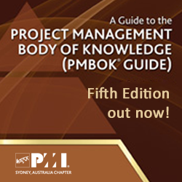
Exam Changes Coming Up Soon!

With the release of PMBoK Fifth Edition, the CAPM and PMP Examination will be changing on the following dates:

CAPM: 1st July 2013
PMP: 1st August 2013

PMI Sydney Chapter offers CAPM and PMP Prep Classes every month. These sessions are very popular and book out fast. From July’13, the prep classes will be following PMBoK 5th ed. Visit the PMI Sydney Certification Preparation Study page for more details.

Download or Order PMBoK Fifth Edition

PMI Members can download a FREE PDF copy from the PMI.org website. You can also purchase a hard copy on PMI Global Marketplace. PMI Members receive 25% discount.

